Natal Readings
Saturday, March 14, 2020
12:21 AM

NATAL ASTROLOGY
Natal Astrology is a branch of astrology commonly used in astrological consulting. It sets focus on a person’s natal chart with its possibilities, potentials and problems, and ways for them to be embraced or resolved. Many astrologers think of it as inseparable from different predictive techniques, but natal and predictive astrology are very much different and mostly differ in the intent of the astrologer to speak of one’s personality or one’s future – two very different things.
How does it Work?
Like all branches of astrology and each specific approach, natal astrology is based on the Theory of Synchronicity, or a claim that our moment of birth and the first breath we took, is in correlation with the Universe and positions of celestial bodies at that time. Many people will be born on the same day, but very few of them at the same time and in the same city. Even among these, differences will be made based on their family members and their upbringing.
The main thing to keep in mind when practicing Natal Astrology is that every single thing in a natal chart has many forms of expression. We live out our natal chart stories every day, and we can recognize them in many other techniques through psychological patterns, energy blockages, daily routine “mistakes”, etc.
About Fear
You will see that many times clients come scared of what their astrologer has to say. But fear doesn’t stop there. Many astrologers will start their panic spree as soon as they see a maleficent planet approaching their Moon or their Ascendant ruler. No matter if you are a practitioner or a client, what you need to keep in mind is – you live out your chart every day. Every aspect and position in it is deeply seeded in your being. You were born with it and just like you can’t run away from your physical body before you dye, you won’t be able to escape your natal chart either, nor should you.
Natal planetary position serves as our base, our airport for anything that will land into our lives throughout them. Challenging aspects will carry their lessons just like beneficent conjunctions will bring us joy, but we cannot live out any scary story that isn’t written in out chart to begin with, and confirmed with at least three predictive methods.
Astrologers and Clients
Every Astrologer has a responsibility to understand the connection they make with a client. This is a bond of two people who both represent planets in each other’s charts. Every astrologer speaks with their own planet in each consultation, and every client listens to one of theirs in return. Pretty much like all the other relationships in our lives, this one will be based on respect and mutual understanding.
Challenges
Astrologer has a task to help the client understand their purpose, their abilities and passions, without interfering in decision making processes explicitly or taking initiative for their client’s life. This contact brings two strong challenges to each practitioner.
The first challenge lies in the fact that a client comes open and fragile to seek help and guidance. This is the emotional challenge that has to be fully understood at all times, so that no hurt is caused and full compassion is established at the start of this relationship.
The second challenge is triggered by trust and responsibility mixed in this complicated mush. While many clients know how to set clear boundaries, their belief in Astrology and hope for a glimpse of an incredible future makes them sensitive to pointless bruises to the ego. An Astrologer has to explain firmly that no event is written in stone and that the client is fully responsible for their own life.
Pre-Reading
The first thing you want to do before reading anyone’s natal chart is read your own. Everything can be found there, including clients, opportunities, difficulties and astrology. Every astrologer needs to know how to interpret their own chart in order to approach a client in any ethical way. In addition, this will lead to many discoveries and a lot of excitement in each of us as we discover how astrology works in our own lives.
Natal Chart Reading
A natal chart reading always begins with the interpretation of an Ascendant. This is the explicit representative of the first breath we took and the point that defines our physical body in this lifetime. The first house will naturally be a part of this physical and basic character interpretation, while the Ascendant ruler represents our guiding planet and points to our greatest focus in this lifetime. We will be sure to observe the first house and its ruler in as much detail as possible, including all the positive and negative aspects to our interpretation, and trying to understand the energy of this incredible mix. It is important to understand planetary symbolism, dignities and the importance of the first house ruler in defining our personality and nature.
Still, it is even more important to never forget that each person is represented by every celestial body, house and sign in their chart. Every single bit of the circle will speak of a bit of our personality, and it seems impossible for the human brain to connect them all into one whole. In lack of a better intellectual tool to bring so many variables together into one image, we have to find other ways to “connect the dots”.
With this said, we have to understand that the only way to truly understand a person is to listen closely and hear what they have to say, sense where they are at the moment, and translate their words into the symbol language of their chart. Only then will we be able to swim out with information of relevance and give all the necessary compassion and respect to the person standing in front of us.
Reading Your Natal Chart: a Visual Guide
This is essentially a guide for beginners so that they can look at their charts, because I know it’s really hard to understand how to see some things. This guide aims to help, especially for my followers who are more visual and example-based learners (like me)!!! So, here we’ve got my natal chart, drawn up on astrotheme.com, like so:
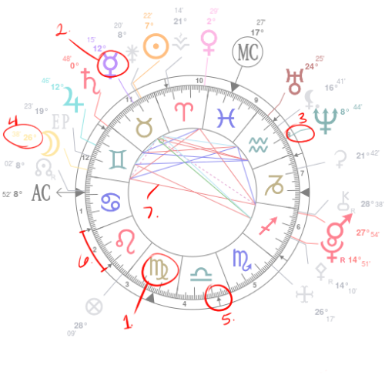
I am going to explain what all of the marked parts are now.
#1. zodiac signs
These are the most basic, yet important parts of the entire natal chart wheel. They will direct the energies of the rest of the chart. If you want to understand charts, it’s important to know what each of these symbols stand for and the relationship they share.
#2. planets
Although better described simply as “positions” since there are also asteroids and angles, these are the symbols for the planets, which represent different parts of an individual’s personality, environment, and culture.
#3. where the planets are
The line in between the planet shows exactly what sign, degree, and house it’s in. This is fairly self-explanatory. You should always make sure to figure out precisely where this line falls (even a single degree can change things).
#4. degrees
Although they don’t really mean much on their own, the degrees can help you see if a planet is in one sign or the other if it’s close to the next sign or house. Some degrees are also said to be significant, of course, like the 1st or 29th degree.
#5. houses
If you look closely, you can see that around the outer ring of the natal chart are little arrows, or if the house is an angle (1, 4, 7, or 10 house), a big arrow tip. This not only shows where the houses begin, but this shows what sign lies in each house. In my natal chart, the circled arrow shows that my 5th house is in libra. You can look in each house to see what house the planets are in. My Moon and Jupiter are in the 12th, for example.
#6. space occupied by houses
You can notice that some houses take up more space than other houses. Make note of where each house starts, and where it ends, so that you make clear note of where each planet is. You don’t want to mistake a planet for being in the next house by accident!
#7. aspects
Finally, in the middle ring of the natal chart, all of the aspects are separated by color. Typically, conjunctions are circles/not shown, square are red, inconjunctions are green, trines are blue, and sextiles are blue, although this can change based off of the software. These show the relationships that each planet has to the other planets, if any.
Hopefully this brief visual guide helped a bit! Good luck in your astrological endeavors, and cheers!

From <https://astrologyandlife.tumblr.com/page/20>

The elements (earth, air, fire, water) are the energy substance of experience.

The signs are the primary energy patterns and indicate specific qualities of experience. Signs are expression – the costumes the actors wear.

The planets regulate energy flow and represent the dimensions of experience. Planets are energy – the actors.

The houses represent the fields of experience wherein specific energies will be most easily expressed and most directly encountered. Houses are environments – the stage on which the actor struts her stuff.

Aspects reveal the dynamism and intensity of experience as well as how the energies within the individual interact. Aspects are the scripts – the dialog between actors who are connected.

The combination of these five factors results in a specific urge toward self-expression and a particular need for fulfillment.

From <https://www.tumbex.com/astrognossienne.tumblr/posts?page=10>

* Basic Rules:
Planets are energy – the actors. They show us WHAT is acting.
Signs are expression – the costumes the actors wear. They show HOW the actors move.
Houses are environments – the stage on which the actor struts her stuff. They show WHERE the action is.
Aspects are the scripts – the dialog between actors who are connected. They show WHY the actors are attracted to each other.
*What Activates Aspects in the Natal Chart
Three things will activate any aspects in the chart: time, place and people. Think of it like this:
Time – Transits to the conjunctions
Place – Relocation or Astre*Carto*Graphy
People – Synastry, as when another person’s planet acts like a transit to yours.

From <http://goodvibeastrology.com/square-aspects-101/>

Explanation of a birth chart
They say a picture is worth a thousand words. While a lot of nonsense seem to come out of "their" mouth, in this particular instance I think they give sound advice. Does the thought of a natal chart full of confusing symbols and lines sound a bit too daunting? Well here's my attempt to explain some of the most important aspects of the natal chart drawing, complete with arrows!
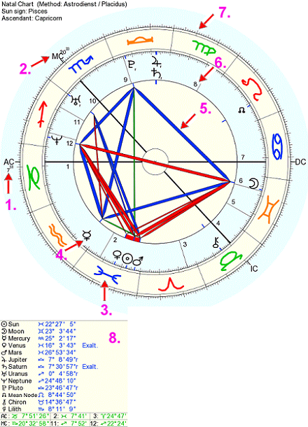
1. The Ascendant
The horizontal line that reaches from the middle left of the horoscope, all the way through the center to the right side marks the horizon at birth. The point of the eastern horizon that "rises" at birth is called the ascendant, AC, and is a very essential feature of your horoscope. It also marks the cusp of the first "house" (see below).
2. The Midheaven
Just as the Ascendant marks the easternmost point of the horoscope, the Midheaven marks the highest point, zenith, of the sky at the time and place of birth. While not as essential as the Ascendant, the Midheaven still has a strong influence. The midheaven marks the cusp of the tenth "house" (see below).
3. Zodiac sign
The section marked with the number 3 is a zodiac sign, in this instance Pisces. One zodiac sign is 1/12 of the "ecliptic", the apparent path of the sun as seen from the earth. Most of you know vaguely what a zodiac sign is. In this context it is an imagined band of 12 equal divisions of the sky, directly based on the actual constellations, both for name and position.
4. Planet
The planets (the different symbols in black) in astrology are very much like the actual planets in the solar system. Except for the fact that the sun and moon also counts as planets in the horoscope. The planets are the dynamic force of our personality, the actors that take on different roles. Planets are "placed" in zodiac signs and houses.
5. Aspect (planetary aspect)
The aspects, or angles, are indicated by the colored lines connecting the planets in the image. In simple terms it is the distance between two planets in the horoscope. Not all distances are relevant though. Traditionally, separations of 0 , 60 , 90 , 120 and 180 have been considered the dominant ones. Aspects create relationships, for good or evil, between factors in our horoscopes and character.
6. House
The houses are the sections of different size marked with numbers 1 through to 12. The division of houses is similar to that of the zodiac, but has a different meaning. It is determined by the point of the ascendant (above) which marks the tip / cusp of the first house. No matter what "house system" is used for determining the size of different houses, the ascendant will always mark the beginning of the first house and end of the twelfth (last).
7. Degree of the zodiac
The very small pin marking a very small section is one of the 360 degrees of the zodiac. No big mystery here - a full circle is 360 degrees and one zodiac sign (out of 12) therefore make up 30 degrees. This is the more finely tuned area of sign placements and planetary aspects.
8. Table of exact positions
A table showing the exact degree-positions of planets and important details like Ascendant and Midheaven.

From <http://www.astroroom.com/horoscope-layout.html>

PART III: INTERPRETING
Now, onto the fun part.
The planets are what is being expressed.
The signs show how you express those things.
The houses show where you express those things.
➳ Start with the planets in the signs.
- The sun is you; if your sun is in Aries, you are an Aries. Your ego, identity, and self-expression will be that of your sun sign.
- The moon is your emotions – you will have the needs of your moon sign and will experience feelings like your moon sign.
- Mercury is communication and thought processes, so you speak and think like your Mercury sign.
- Venus is your view of art & beauty and the way you show love, so you’ll be like your Venus sign in areas of your personality that concern those things.
- Mars is your drive, passion, sexual desire, anger, and ambition, so your Mars sign will influence those parts of you.
- Jupiter | Saturn | Uranus | Neptune | Pluto
- Read about the signs & planets and then take that information and translate your chart into it. You can also Google any placement and find satisfactory interpretations of them. Here is a page with descriptions for everything.
➳ Once you know what your planetary positions are and you understand their meanings, you can move on to the houses in the signs. As previously mentioned, the houses are mathematical points that signify areas of life, so the sign they are in will describe how you handle that area of your life. After that should come planet-in-house interpretation. Planets’ energies will be confined to, primarily directed at, or especially concerned with the area of life the house they’re in is associated with. Again, you can Google those placements.
➳ Finally, the aspects are very crucial factors in the natal chart. Neutral aspects (conjunction, quincunx) describe a relationship between planets or other points which can be both negative or positive depending on the compatibility of energies involved and how the native psychologically handles their contact. Harmonious aspects (sextile, trine) describe relationships that promote ease and peaceful planetary interactions within a chart, whereas discordant aspects (square, opposition) describe relationships that cause difficulty and conflict within the native. There are many, many minor aspects to look into as well, but here is a post that explains the most important ones. Here is another post that may come in handy.
➳ Dominant signs, planets, houses, modes, and elements have particular influence over an individual’s birth chart and are worth looking into. When something is dominant, it is simply especially prominent and powerful in comparison to other components of its nature. Here is a post that outlines imperfect but generally reliable methods of calculating dominants manually.
➳ Chart lords (AKA house rulers) are additional ways of finding extensive, indirect influences throughout your chart. Here is a post that explains them.

From <https://astral-obscura.tumblr.com/tagged/mypost/page/22>

Important, Significant and Unique Birth Chart Conditions
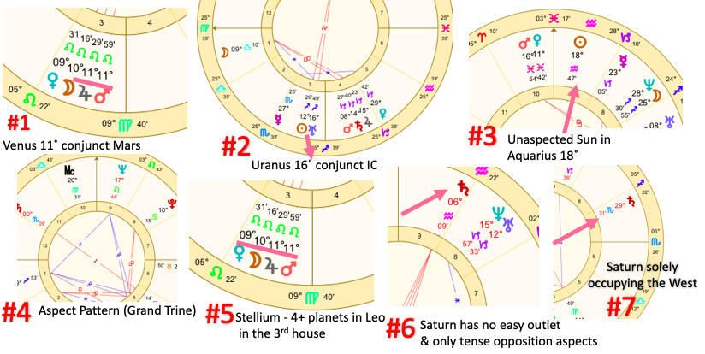
  - Planets making exact aspects by degree (O˚ orb or difference of separation) like in chart #1 with Venus 11˚ conjunct Mars in Leo 11˚
  - Planets within 10˚ of the angular houses (1st, 4th, 7th, 10th) like in example#2 where Uranus is 16˚ Sagittarius and the 4th house cusp is 25˚)
  - The Sun in opposition to the Moon (Full Moon) or the Sun conjunct Moon (New Moon)
  - Planets making no aspects (unaspected planets) like in chart#3 where the Sun in Aquarius is sitting by itself
  - Signs in their own ruling planet (Mars in Aries and Scorpio, Venus in Taurus and Libra, Mercury in Gemini and Virgo, Moon in Cancer, Sun in Leo, Pluto in Scorpio, Jupiter in Sagittarius, Saturn in Capricorn and Aquarius, Uranus in Aquarius, Jupiter and Neptune in Pisces)
  - Planets that form a Mutual Reception occurring when two signs reside in one another’s ruling planet and share or exchange energies out of benefice … for example, if The Sun is in Aquarius and Saturn is in Leo a mutual reception occurs because the Sun rules Leo and Saturn rules Aquarius and we interpret this as the Sun being in Leo and Saturn in Aquarius
  - Aspect Patterns such as Grand Trines, Grand Crosses, Grand Squares, T-squares, and strong oppositions such as the Grand Fire Trine in chart#4
  - Stelliums (4+ planets in the same sign or house) shown in chart#5 where Venus, Moon, Jupiter, and Mars are conjunct in Leo in the 3rd house
  - The ‘Splay’ chart temperament type or a chart configurations that adhere to no pattern or temperament type
  - Planet with the most aspects, or planets stimulated exclusively by the harsh aspects like conjuncts, squares, and oppositions example#6, and focal point planets that filter the chart such as the handle planet in the bucket chart
  - One planet solely occupying a complete hemisphere like in chart#7 where the only sign in the West is Saturn in Scorpio in the 7th house

From <https://godtiervenus.tumblr.com/>

tips for interpreting your birth chart:
  - see how the ascendant puts the 12 signs into the houses one by one. Aries rising places Taurus in the 2nd house, Gemini in the 3rd, and so on. those will be the topics describing said areas of life. e.g. you will act Venusian in relationships if Libra is in your 7th house.

  - knowing your chart ruler and how it functions in its spot is the most important thing. you can find it by checking which planet governs your rising sign. e.g. if you’re a cancer asc, the aspects, sign, and house placement of your moon reflect the theme of your life to a high degree. traditional rulership is pretty interesting, so — attention Scorpio rising, look at Pluto but you are also co-ruled by mars. Aquarius ac, look at Uranus, but Saturn also. Pisces asc, check Jupiter next to Neptune.

  - dignity and debilitation is key. beside rulership of the signs, keep in mind how certain planets to well or are stifled in specific signs. learn about exaltation, detriment and fall (table). knowing that mercury is at home in Gemini or Virgo is crucial to interpret your chart, but also how Saturn is exalted in Libra or how Venus falls in Aries. most of it is intuitive, e.g. see how Venus’ gentle nature clashes with Aries' martial approach.

  - the moon sign is your true identity. how you act when you are by yourself. like the actual moon is serenely present at night in darkness. if you want to know how your crush is really like, their lunar placement will tell you. meanwhile, the sun sign is your self-presentation. the sun is ruled by Leo after all, that’s how you want to prove and establish yourself. there’s attachment. the sun sign is a mask. at the end of the day, where you find true comfort is only the moon sign and its house.

  - followed by the Venus sign which symbolizes everything you find nice and pleasing. you’ll notice how your coping mechanisms — caused by your sun sign’s struggle — are all in these moon or Venus areas. realize that you don’t need a reason of pressure to comfort yourself or admit to those areas that make you feel great. let Venus be Venus for its own sake.

  - a lot of value can be drawn out of interpreting the IC versus the MC. that is, how your childhood life leads to your career life. the contrast of the 4th house (domestic) and the 10th house (public) is in a natural opposition with good reason, 180° apart. you will find a fulfilling career if it brings balance to what happened in the home.

  - accept squares as they are. a lot of astrologers try to pull something positive out of them, but the experienced ones tell you that you can’t overcome them, it’s supposed to be like that. all that’s possible is using your sextiles and trines to get back on track. and it is true that the more squares, the more karmic rewards. oppositions, even more so. especially when Saturn is involved, there will be benefits down the line.

  - see where your parents’ north nodes are. even if you don’t have their birth times, you can find it. now, if you have any personal planets in your own chart at those very spots, it is likely that your parents wanted you to fulfill their purpose for them. if your mother’s north node is in Taurus and you are a Taurus sun, she passed on a need for stability in life. that purpose is not complete by her own efforts, you continue it. in essence, the north node tells you the people you’re bound to. the south node shows you people you were bound to.

  - predict the time of meeting a spouse by your Jupiter return. if Jupiter visits your natal Jupiter sign again, it’s due. Venus being in good aspect or conjunction shows an increased likelihood. the presence of Saturn there indicates it takes more time and growth. until Saturn leaves the conjunction, opposition or square, the Jupiter return’s effect will be delayed. but: you will be much wiser and experienced afterwards, and your partner will be time-tested and a quality spouse.

  - if you want to know in which place or environment you can find love in at the moment, calculate which house of yours Venus currently transits. e.g. if it transits your 9th house you can find love abroad, in the 10th house at the workplace, in the 11th online.

From <https://trashittarius.tumblr.com/>

How to read/calculate your birth chart
From time to time I get people who are absolutely brand new to astrology, so I figured I should make this post and add it to my FAQ for reference. In this post I’ll demonstrate step by step how to calculate and read your chart via Astro.com.
*This is just a simple guide; you will still be required to research on specific topics such as basic understanding of symbols in astrology.
Calculating Your Chart
Step 1
Create an account on Astro.com
Step 2
Under ‘Free Horoscopes,’ you will find ‘Extended Chart Selection’ and it will take you to the chart calculating/format page.
Step 3
If you haven’t already inputted your birth info, you can do this now under ‘Add a New Person’
On the Extended Chart Selection page, it gives you options for how your chart will be calculated and formatted. The default House System will likely be set to “Placidus,” but I strongly recommend changing this to “equal” as it will be easier to understand and is the way I read birth charts.
You don’t need to change any other settings from here, however you’re welcome to. Under ‘Display and calculation options” you can adjust what planets or objects will be included in your chart, you can adjust the aspect orb, and you can change aspect allowances. Under ‘Additional objects’ you can choose to include certain asteroids and objects as well. I personally like to include Pallas, Ceres, Vesta, and Juno, but these are by no means required.
Step 4
‘Click here to show the chart’ will take you to the actual chart page. This is your calculated chart.
(This is my chart with my personal settings)
The table below the circular chart lists the placements and aspects. Take note of the planetary symbols next to their names as this will help you learn the symbols and understand the circular chart better.
The aspect chart (the staircase looking table) can be read by looking at one of the symbols (triangle, square, angle, etc.) and the planetary symbol above it and the planetary symbol to the right indicates which two planets are making this aspect. This page on Astro will give you a brief explanation on what the aspect symbols are. You definitely do not need to focus on aspects if you’re a beginning, but this may be good to refer back to when you’re ready to learn about them.
Looking at the circular chart, you’ll notice it resembles a pie with twelve slices. You will see that these twelve slices are numbered (near the centre). These numbers represent the Houses. Where the houses start is indicated by your Ascendant (AC in your chart. Ascendant can also be referred to as Rising sign). From the exact degree of your Ascendant, 12 slices can be marked around the circle in 30 degree intervals. In my case, my ascendant is marked at 22 degrees in Leo therefore my first house starts at 22 degrees in Leo, my second house starts at 22 degrees in Virgo, my third house starts at 22 degrees in Libra, and so on. The equal 30 degree slices are the result of the equal house system; other house systems will give you different house layouts. Placidus, for example, will give you different sized houses starting at different points (so you might be able to see why I recommend the equal house system.)
Still looking at the circular chart, you will see the planetary symbols sitting in these pie slices with a little number next to them. The little number next to the planetary symbols indicates in what degrees the planet is in the sign (note; the SIGN, not the house. The signs have their own ‘cusps’ apart from the houses which are also in 30 degree increments). So if you take a look at my Sun for example (circle with a dot symbol) it is sitting in the 4th pie slice (fourth house) at 16 degrees in Sagittarius.
If you continue to look at my Sun in the 4th in Sagittarius, you will notice that a red line is pointing to it and connecting to Jupiter. This is considered an aspect. Aspects show the relationships between planets in our birth chart. If you refer back to the staircase table and where the Sun meets Jupiter, you will see a square symbol. This symbol indicates that the Sun and Jupiter are forming a square aspect.
The 3x4 table to the right of the staircase table keeps score of how many planets of the same element or same mode you have. C - Cardinal, F - Fixed, M - Mutable and F/Red - Fire, A/Yellow - Air, E/Green - Earth, W/Blue - Water. This will give you a basic and quick idea of the general emphasis of your chart. It only takes you really a second to realize that I’m a fire dominant with a significant lack of earth just by looking at this table.
Reading Your Chart; Where to Start?
1. The Big Three
Locate your Sun, Moon, and Ascendant. These three placements are almost always the most important placements in your chart. Identify their meanings, their significance to the house they are in, and look into what their relationships are with other planets in your chart.
2. Your Chart Ruler
Your ascendant indicates what your chart ruler is. Your chart ruler is the planet that your ascending sign rules over. For example, if you are a Taurus and Libra ascendant, then your chart ruler would be Venus. Look at the condition of your chart ruler, is it in a sign that works well for it? What aspects are being made to it? What house is it in?
3. Day VS Night Chart
Your ascendant’s line is what divides the chart into two hemispheres. The top half of your chart is considered the Southern Hemisphere whereas the bottom half is considered the Northern Hemisphere. Depending on if your Sun is placed above (Southern) or below (Northern) the ascendant’s line will indicate whether you have a Day chart or a Night chart. In Day charts, the Sun has more priority and the chart’s main benefic planet is Jupiter. In Night charts, the Moon has more priority and the chart’s main benefic planet is Venus. You can find many other significances with Day VS Night charts that are worth researching into.
4. North Node
Your North Node placement is going to be one of the most eye-opening placements to look into. Definitely should not go overlooked.
5. Midheaven
Your Midheaven, also synonymous with your 10th house, gives some insight to future career or life goals. This represents where you will build your legacy.
6. Love indicators (for those who are interested in this)
Your chart can imply insight to how you behave in love and the type of people you attract/may be most compatible with. The points you will want to research for this are Venus (romantic expression/aesthetic expression), Mars (sexual expression), and your Descendant/7th house. The asteroid Juno is a bonus you may want to look into.
7. Jupiter and Saturn.... And the rest of the planets
Eventually you’ll want to look into the rest of the planetary positions in your chart. Jupiter typically suggests our eases and opportunities in life whereas Saturn indicates inhibitions and fears. There’s some really interesting things to unpack from these planets based on their sign and house position. When looking at the planets, you should also consider their condition as planets do better in certain signs and worse in others. This is considered exaltation VS debilitation. Outside of a planet’s ruled sign, it has a sign it exalts in, a sign it is debilitated in, and a sign it is detriment in. Planets in their ruling or exalted sign have significant influence on the chart.
8. What stands out?
When you look at your chart, what stands out to you? Any particular aspect shapes? Any over emphasis in one sign (Stellium)? Any major conjunctions? If it stands out, it’s likely important and should be looked into. Take my chart for example, there is a very obvious triangle shape in it; this is called a grand trine. There are other chart patterns too, as this is just one, that can lead a big impact in one’s chart.
9. Literally at this point, go down the rabbit hole.
By this point, you would have gone over many of the main points of your chart and you can explore any particular point or section now! Aspects? The rest of the houses? Asteroids maybe?
To summarize, I want to emphasize that this is just a simple guide that will require research. Google, books, and forums are your best friend when it comes to researching astrology. Overall, I hope this post makes sense.

From <https://www.tumblr.com/dashboard>

